# Compass - Transmission Details

Transaction IN / Transaction OUT

Transaction IN

Participant

Pharmacy

Prescription (Rx)

Financial

Other

Transaction OUT

Transmission Information

Messages

Financial

Benefit Stage Loop

Reject DUR

Other

COB Segment Screen

Related Documents

**Description:** Details regarding the information found within the Transmission Details screen in Compass. The Transmission Details screen displays most common fields used in resolution of rejects.

|  |
| --- |
| **Transaction IN / Transaction OUT** |

The Transmission Details screen contains the Transaction IN and Transaction OUT sections.

Refer to the following:

**Note:** To expand collapsed sections, click the **Summary** toggle on the right. 

**Result:**  Collapsed sections open and the Summary toggle updates. 

Top of the Document

|  |
| --- |
| **Transaction IN** |

The Transaction IN section contains the following collapsible subsections:

Participant

Pharmacy

Prescription

Financial

Other

Top of the Document

|  |
| --- |
| **Participant** |

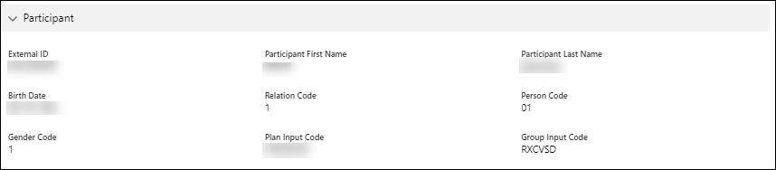

|  |  |  |  |
| --- | --- | --- | --- |
| **Field** | **Description** | **Causes for Rejects** | **Suggestions for Resolution** |
| **External ID** | Displays the submitted Member ID number | * **Reject 07** Missing / Invalid Cardholder ID Number * **Reject 52** Non-Matched Cardholder ID number | Verify if the ID is submitted correctly, |
| **Participant First Name** | Displays the submitted first name | * **Reject CA** Missing / Invalid Patient’s First Name * First name spelled incorrectly * Multiple birth claims, claim is adjudicating under first line of multiple births | * Verify if the spelling is the same as found in Compass. * Verify if the correct member is showing for multiple births. |
| **Participant Last Name** | Displays the submitted last name | * **Reject CB** Missing / Invalid Patient’s Last Name * Last name is spelled incorrectly | * Verify if the spelling is the same as found in Compass. * Verify if the correct member is showing. |
| **Birth Date** | Displays the submitted Date of Birth (**DOB**) | * **Reject 09** Missing / Invalid Birth Date * Pharmacy submitted the incorrect DOB. | Verify if the Date of Birth is the same found in Compass. |
| **Relation Code** | Displays the pharmacy submitted relation code | * **Reject 11** Missing / Invalid Relationship code * Pharmacy submitted the incorrect Relation code. | Verify if the Relation Code is the same found in Compass. |
| **Person Code** | Displays the submitted person code | * **Reject 08** Missing / Invalid Person code * **Reject 53** Non-Matched Person Code * Pharmacy submitted incorrect person code | Verify if the person Code is the same found in Compass. |
| **Gender Code** | Displays the submitted Gender Code | * **Reject 10** Missing / Invalid Patient Gender code * Pharmacy submitted incorrect Gender code. | Verify if the gender code is the same found in Compass. |
| **Plan Input Code** | Displays the submitted **PCN** (Processor Control Number) Code | * **Reject 04** Pharmacy submitted the incorrect PCN | Verify the PCN in the Retail Logic section of the Client Information Form (**CIF**) in theSource. |
| **Group Input Code** | Displays the submitted RxGroup Code | * **Reject 06** Pharmacy submitted the incorrect RxGroup | Verify the RxGroup in the Retail Logic section of the CIF in theSource. |

Top of the Document

|  |
| --- |
| **Pharmacy** |

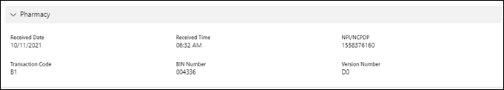

|  |  |  |  |
| --- | --- | --- | --- |
| **Field** | **Description** | **Causes for Reject** | **Suggestion for Resolution** |
| **Received Date** | Date the claim was submitted for processing. | Not applicable | Not applicable |
| **Received Time** | Time the claim was submitted for processing. | Not applicable | Not applicable |
| **National Provider Identifier (NPI)/** **National Council for Prescription Drug Programs** **(NCPDP)** | Displays the NPI submitted by the pharmacy | **Reject 05** Missing / Invalid Service Provider Number. | If the pharmacy cannot add their NPI; they need to contact:   * Chain – their Headquarters * Affiliate/Independents – Software Vendors |
| **Transaction Code** | Displays the pharmacy submitted Transaction Code.  D.0 only allows transaction code:  B-1 (Claim).  B-2 (Reversal). | **Reject 03** Missing / Invalid Transaction code. | * Verify with the pharmacy what type of transaction they are processing. * Pharmacy should resubmit with transaction code of 1 if they are processing a claim or 2 if they are reversing a claim. |
| **Bank Identification Number** **(BIN) Number** | Displays the pharmacy submitted BIN number.  Each Pharmacy Benefit Manager (**PBM**) platform has its own BIN number. This is used by the switching station to send the transaction to the correct PBM platform. | **Reject 01** Missing / Invalid BIN Number | Verify the BIN in the Retail Logic section of the CIF. |
| **Version Number** | Displays the version submitted by the pharmacy.  Version used today D.0 | **Reject 02** Invalid version number. | Pharmacy should resubmit claims with Version number D.0. |

Top of the Document

|  |
| --- |
| **Prescription (Rx)** |

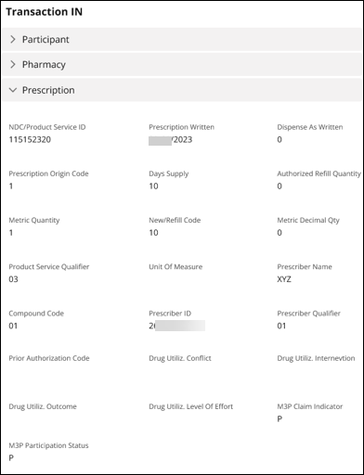

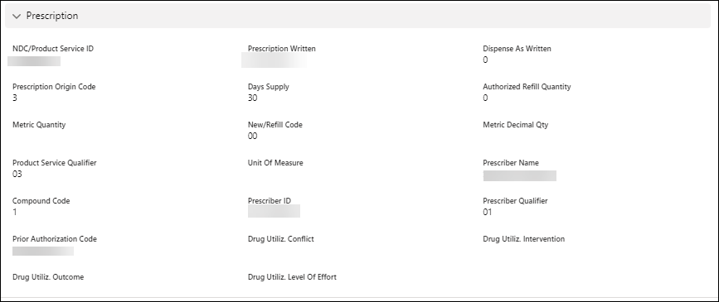

|  |  |  |  |
| --- | --- | --- | --- |
| **Field** | **Description** | **Causes for Reject** | **Suggestion for Resolution** |
| **National Drug Code** **(NDC)/Product Service ID** | Displays the submitted drug’s NDC number | **Reject 16** Missing / Prescription number | * If the prescription number is NOT being displayed, the pharmacy needs to resubmit with a prescription number. * If the pharmacy cannot update prescription number; they need to contact:   + Chain – their Headquarters   + Affiliate/Independents – Software Vendors |
| **Prescription Written** | Displays the date the doctor wrote the prescription. | **Reject 28** Missing / Invalid Prescription Date  The Prescription date is outside of the prescription filling window.  **Example:** Most common drug prescriptions are good for one year. | Pharmacy should resubmit claim with valid prescription written date. |
| **Dispense as Written** | A prescribing directive to pharmacists to dispense only the medication ordered:  Prevents generic drug substitution. Also see **PSC** (Product Selection Code) codes.  0 - No DAW indicated  1 - Dispense as written by the prescriber  2 - Substitution allowed, member requested brand.  3 - Substitution allowed, pharmacist requested brand  4 - Generic available, not in stock  5 - Substitution allowed, brand dispensed as generic  6 - Override  7 - Brand mandated by law  8 - Substitution allowed, no generic available in marketplace  9 – Other | Not applicable | Not applicable |
| **Prescription Origin Code** | Pharmacy submitted value on how the pharmacy received the prescription:  1 = Written  2 = Telephone  3 = Electronic  4 = Facsimile  5 = Pharmacy (indicates the pharmacy created new Rx from an existing valid Rx number) | Not applicable | Not applicable |
| **Days’ Supply** | Displays the submitted day supply | Not applicable | Not applicable |
| **Authorized Refill Quantity** | Displays the submitted number of refills from the prescription | Not applicable | Not applicable |
| **Metric Quantity** | NOT USED BY PHARMACY HELP DESK | Not applicable | Not applicable |
| **New/Refill Code** | Fill Number submitted by the pharmacy:  0 (zero) = Original Dispensing  1 to 99 = Refill number | Not applicable | Not applicable |
| **Metric Decimal Quantity** | NOT USED BY PHARMACY HELP DESK | Not applicable | Not applicable |
| **Product Service Qualifier** | Displays Product Service Qualifier submitted by the pharmacy.  Product Service Qualifier = 3 | Pharmacy submitted an invalid product service qualifier. | Pharmacy should resubmit claim with product service number 3. |
| **Unit of Measure** | NOT USED BY PHARMACY HELP DESK | Not applicable | Not applicable |
| **Prescriber Name** | Displays Prescriber Name submitted by the pharmacy | **Reject 71** Prescriber is NOT Covered. | * Prescriber is NOT Covered under the plan (HMO). * Office of Inspector General (**OIG**) (Federal Excluded Provider or State Excluded Provider Edits). |
| **Compound Code** | Compound code submitted by the pharmacy.  2 = Compound  1 = NOT Compound  0 = Non-specified | Not applicable | Not applicable |
| **Prescriber ID** | Displays Prescriber ID submitted by the pharmacy | * **Reject 42** Pharmacy submitted invalid individual NPI number. * **Reject 46** Prescriber Drug Enforcement Agency (**DEA**) submitted does not allow this drug DEA schedule. * **Reject 56** Non-Matched Prescriber ID. | Pharmacy should resubmit the claim with a valid individual NPI number. |
| **Prescriber Qualifier** | Displays Prescriber ID Qualifier submitted by the pharmacy.  Prescriber ID Qualifier = 1. | Invalid Prescriber ID Qualifier submitted by the pharmacy. | Pharmacy should resubmit the claim with a Prescriber ID Qualifier of 1. |
| **Prior Authorization Code** | Displays the Prior Authorization/Medical Certification (**PAMC**) number submitted by pharmacy | Claim will be rejected if Invalid PAMC is used unnecessary. | Not applicable |
| **Drug Utiliz. Conflict** | Displays the pharmacy submitted information | **Reject E4** Missing / Invalid Reason for Service Code | * **Vaccines Claims** – The pharmacy should resubmit claim with this field blank. * **Overrides** – The pharmacy should resubmit the claim with the correct reason for service code. |
| **Drug Utiliz. Intervention** | Displays the pharmacy submitted information. | **Reject E5** Missing / Invalid Professional Service Code | * **Vaccines** – The pharmacy should submit the claim with **MA** (Medication Administration) when requesting an Administration Fee.   **Note:** When the pharmacy submits a claim with MA, the claim will reject if the plan sponsor does **not** cover administration for this vaccine   * **Overrides** - The pharmacy should resubmit the claim with the correct Professional Service code. |
| **Drug Utiliz. Outcome** | Displays the pharmacy submitted information. | **Reject E6** Missing / Invalid Result of Service Code | * **Vaccines Claims** – The pharmacy should resubmit claim with this field blank. * **Overrides** – The pharmacy should resubmit the claim with the correct result of service code. |
| **Drug Utiliz. Level Effort** | Displays the pharmacy submitted level of effort 11 – 15 for Compounds. | Cause no rejects | If the pharmacy submits an incorrect level of effort, the pharmacy reimbursement will be effect. |
| **M3P Claim Indicator** | Displays when claim was processed through the Medicare Prescription Payment Plan (**M3P**).  Options are as follows:   * **Y –** M3P Paid * **X –** M3P Reversed by Pharmacy * **Z –** M3P Billing with $0 * **M –** M3P Paid COB * **I –** Claim ineligible for M3P * Blank   **Note:** The program is abbreviated as MPPP by CMS and may be known by members as MPPP. At this time, the program is referred to as M3P in the Compass system. | Not applicable | Not applicable |
| **M3P Participation Status** | Displays Medicare Prescription Payment Plan (**M3P**) eligibility.  Options are as follows:   * **P –** Participating / Eligible * Blank – Not participating   **Note:** The program is abbreviated as MPPP by CMS and may be known by members as MPPP. At this time, the program is referred to as M3P in the Compass system | Not applicable | Not applicable |

Top of the Document

|  |
| --- |
| **Financial** |

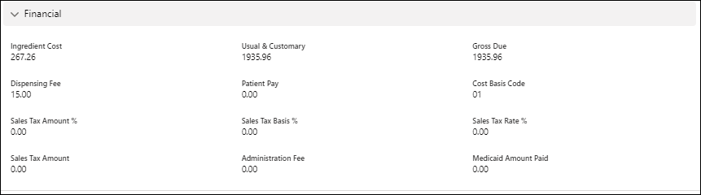

|  |  |  |  |
| --- | --- | --- | --- |
| **Field** | **Description** | **Causes for Reject** | **Suggestion for Resolution** |
| **Ingredient Cost** | Displays the pharmacy submitted Ingredient cost amount. | * Cause no rejects * **Reject DN** Missing / Invalid Basis of Cost Determination | * Pharmacy needs to resubmit claim with Ingredient Cost amount. * If the pharmacy submitted an incorrect amount, it may cause incorrect reimbursement. |
| **Usual & Customary** | Displays the pharmacy submitted Usual & Customary amount | **Reject DQ** Missing /Invalid Usual & Customary | * Pharmacy needs to resubmit claim with Usual & Customary amount. * If the pharmacy submitted an incorrect amount, it may cause incorrect reimbursement. |
| **Gross Due** | Displays the pharmacy submitted Gross Due | Not applicable | Not applicable |
| **Dispensing Fee** | Displays dispensing fee submitted by the pharmacy | Cause no rejects | If **no** dispensing fee is submitted, the pharmacy is **not** reimbursed for a dispensing fee. |
| **Patient Pay** | Displays patient pay submitted by the pharmacy | Cause no rejects | System calculates the Patient pay. |
| **Cost Basis Code** | Warm transfer to the Senior Team when claim rejects to these fields. | | |
| **Sales Tax Amount %** |
| **Sales Tax Basis %** |
| **Sales Tax Rate %** |
| **Sales Tax Amount** |
| **Administration Fee** | Warm transfer to the Senior Team when claim rejects to these fields.  **Note:** Most common; used when billing compound claims. | | |
| **Medicaid Amount Paid** | Warm transfer to the Senior Team when claim rejects to these fields. | | |

Top of the Document

|  |
| --- |
| **Other** |

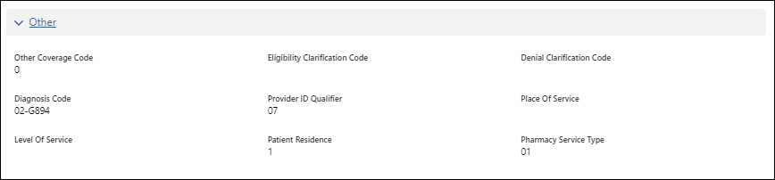

|  |  |  |  |
| --- | --- | --- | --- |
| **Field** | **Description** | **Causes for Reject** | **Suggestion for Resolution** |
| **Other Coverage Code** | Displays the pharmacy submitted Other Coverage Code  Other Coverage Code is **2, 3, 4, 5, 6, 7, 8** | **Reject 13** Missing / Invalid Other Coverage code | **For COB Segment Billing:**   * Use value 2 when the previous payer paid the claim. * Use value 4 when payment. * was not collected due to previous payer(s) deductible. * Use values 3, 5, 6, 7 when payment was not collected from the previous payer.   **For Copay only Billing:**   * Use values 3, 5, 6, 7 when payment was not collected from the previous payer. * Use value 8 when the previous payer paid the claim. |
| **Eligibility Clarification Code** | Field NOT required for adjudication of claims. | | |
| **Denial Clarification Code** | Field NOT required for adjudication of claims. For further information (clarification or possible resolution) on the nature of the specific rejection, please see the following Work Instruction: [Compass - Rejection Codes and Resolutions (Reject 01 – Reject ZN) (067649)](https://thesource.cvshealth.com/nuxeo/thesource/#!/view?docid=104c3318-95ba-42e2-bd05-17877b0a8045). | | |
| **Diagnosis Code** | Displays the pharmacy submitted Diagnosis code obtained for the Provider. | | |
| **Provide ID Qualifier** | * Displays the pharmacy submitted Provider Qualifier ID. * Provider Qualifier ID should be = 7. | | |
| **Place of Service** | Field is no longer used in adjudication. | | |
| **Level of Service** | Field is no longer used in adjudication. | | |
| **Patient Residence** | Displays the pharmacy submitted Pharmacy Residence code.  Valid Patient Residence Code Values:  **0, 1, 3, 4, 6, 9, 11** | **Reject U7** Missing / Invalid Patient Residence | Pharmacy needs to resubmit claim a valid Patient Residence Code value. |
| **Pharmacy Service Type** | Displays the pharmacy submitted Pharmacy Service Type.  Valid Pharmacy Service Type Codes values:  **1-8 and 99** | **Reject 4X** Missing/ Invalid Pharmacy Service Type | Pharmacy needs to resubmit claim a valid Pharmacy Service Type Code value. |

Top of the Document

|  |
| --- |
| **Transaction OUT** |

The Transaction OUT section contains the following collapsible subsections:

Transmission Information

Messages

Financial

Benefit Stage Loop

Reject DUR

Other

Top of the Document

|  |
| --- |
| **Transmission Information** |

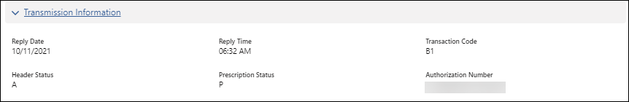

|  |  |
| --- | --- |
| **Field** | **Description** |
| **Reply Date** | Transmission Reply Date to the pharmacy |
| **Reply Time** | Transmission Reply Time to the pharmacy |
| **Transaction Code** | Type of Transaction   * B-1 (Claim) * B-2 (Reversal) |
| **Header Status** | Not used by Pharmacy Help Desk |
| **Prescription Status** | Displays the status of the claim:   * P = Paid * R = Rejected |
| **Authorization Number** | Displays the authorization number that allowed the claim to pay. |

Top of the Document

|  |
| --- |
| **Messages** |

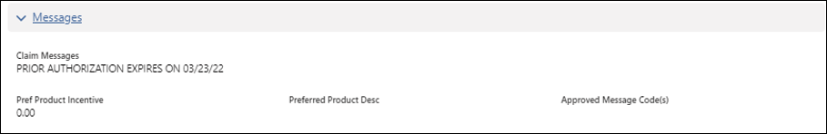

|  |  |
| --- | --- |
| **Field** | **Description** |
| **Claim Message** | Displays the claim Message returned to the pharmacy |
| **Pref Product Incentive** | Describes payment adjustment based on Merit-based Incentive |
| **Preferred Product Desc** | Describes the preferred product specific to the therapeutic drug class |
| **Approved Message Codes(s)** | Message code, on an approved claim/service, communicating the need for an additional follow-up |

Top of the Document

|  |
| --- |
| **Financial** |

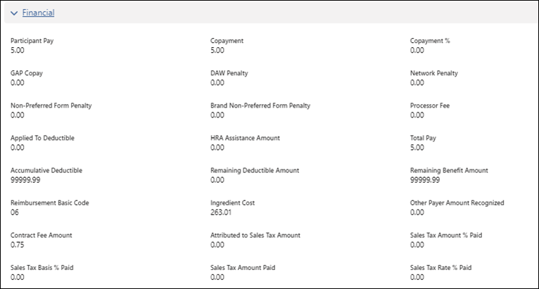

|  |  |
| --- | --- |
| **Field** | **Description** |
| **Participant Pay** | Displays participant pay submitted by the pharmacy. |
| **Copayment** | The plan member’s co-payment (Out-of-pocket) amount is based on their plan design. |
| **Copayment %** | Generally, a fixed percentage amount required to be paid by the member before or after meeting an established policy deductible. May be interchanged with term ‘Coinsurance.’ |
| **non preAP Copay** | (Med D) Specified amount or percentage a Medicare D beneficiary pays after reaching the initial coverage limit. Refer to CIF. |
| **DAW Penalty** | Additional amount (as specified in the members’ prescription plan design. See CIF) the member paid for having the prescription filled with a brand medication when a generic was available. When speaking to members, do **not** use the word “penalty” but rather refer to it as a DAW Cost Difference. |
| **Network Penalty** | Client Specific, refer to CIF. When speaking to members, do **not** use the word “penalty” but rather refer to it as a **Network Surcharge**. |
| **Non-Preferred Form Penalty** | Displays the cost amount of the non-preferred formulary cost amount. When speaking to members, do **not** use the word “penalty” but rather refer to it as a Non-Preferred Form Surcharge. |
| **Brand Non-Preferred Form Penalty** | Displays the cost amount of the brand non-preferred formulary. When speaking to members, do **not** use the word “penalty” but rather refer to it as a Brand Non-Preferred Form Surcharge. |
| **Processor Fee** | Displays the amount to be collected from the patient for processing imposed by the processor. |
| **Applied To Deductible** | Amount applied to deductible. |
| **HRA Assistance Amount** | Displays the amount applied from the patient’s health reimbursement arrangement by their employer (may be negative). |
| **Total Pay** | Displays the amount subtracted from the Drug Benefit is the end result, after Other Payer Amount Paid values are subtracted. |
| **Accumulative Deductible** | Displays the amount met by patient/family in a deductible plan. |
| **Remaining Deductible Amount** | Displays the amount remaining to pay before insurance pays the copays/coinsurance. |
| **Remaining Benefit Amount** | Displays the remaining amount the insurance pays towards a claim/benefit. |
| **Reimbursement Basic Code** | Displays the code that describes the pharmacist services. |
| **Ingredient Cost** | Fee charged by the pharmacy along with the ingredient costs and other charges. The fee is determined by the complexity of decision-making or resources utilized by a pharmacist to perform a professional service. |
| **Other Payer Amount Recognized** | Not Used by Customer care. |
| **Contract Fee Amount** | Displays the fee between the pharmacy and the insurance carrier. |
| **Attributed to Sales Tax Amount** | Displays the dollar value of the portion of the copay which the member is required to pay due to sales tax on the prescription. |
| **Sales Tax Amount % Paid** | Displays the tax percentage amount. |
| **Sales Tax Basis % Paid** | Displays the percentage amount paid. |
| **Sales Tax Amount Paid** | State and local taxes levied on the sale of prescription drugs. |
| **Sales Tax Rate % Paid** | Displays the percentage rate paid. |

Top of the Document

|  |
| --- |
| **Benefit Stage Loop** |

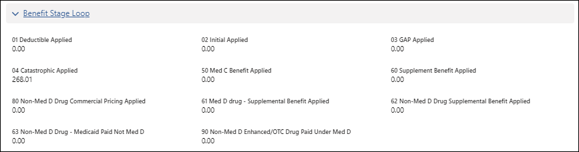

|  |  |
| --- | --- |
| **Field** | **Description** |
| **01 Deductible Applied** | The amount applied towards the specified amount the member must pay out-of-pocket prior to the plan paying the copay/coinsurance. |
| **02 Initial Applied** | The deductible amount paid prior to the specific claim processed. |
| **03 GAP Applied** | The GAP amount applied towards the specific claim processed. |
| **04 Catastrophic Applied** | The Catastrophic amount applied towards the specific claim processed |
| **50 Med C Benefit Applied** | The Med C amount applied towards the specific claim being processed |
| **60 Supplement Benefit Applied** | The Supplement Benefit amount applied towards the specific claim processed |
| **80 Non-Med D Drug Commercial Pricing Applied** | The Non-Med D Drug Commercial Pricing applied towards the specific claim processed |
| **61 Med D drug – Supplemental Benefit Applied** | The Med D Drug -Supplemental Benefit applied towards the specific claim processed |
| **62 Non-Med D Supplemental Benefit Applied** | The Non-Med D Drug -Supplemental Benefit applied towards the specific claim processed |
| **63 Non-Med D Drug – Medicaid Paid Not Med D** | The amount applied towards the specific claim processed Non-Med D Drug Medicaid is not paid towards Med D |
| **90 Non-Med D Enhanced/OTC Drug Paid Under Med D** | The amount applied towards the specific claim processed to Non-Med D Enhanced/OTC Drugs paid under Med D |

Top of the Document

|  |
| --- |
| **Reject DUR** |

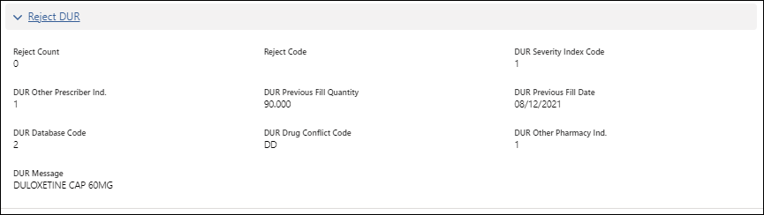

|  |  |  |  |
| --- | --- | --- | --- |
| **Field** | **Description** | **Causes for Reject** | **Suggestion for Resolution** |
| **Reject Count** | Displays the number of rejects on the claim. | Not applicable | Not applicable |
| **Reject Code** | Displays the NCPDP D.0 Rejection code returned to the pharmacy. | Not applicable | Not applicable |
| **DUR Severity Index Code** | Not applicable | Not applicable | Not applicable |
| **DUR Other Prescriber Ind.** | Not applicable | Not applicable | Not applicable |
| **DUR Previous Fill Quantity** | Not applicable | Not applicable | Not applicable |
| **DUR Previous Fill Date** | Not applicable | Not applicable | Not applicable |
| **DUR Database Code** | Not applicable | Not applicable | Not applicable |
| **DUR Drug Conflict Code** | Not applicable | Not applicable | Not applicable |
| **DUR Other Pharmacy Ind.** | Not applicable | Not applicable | Not applicable |
| **DUR Message** | Not applicable | Not applicable | Not applicable |
| **Drug Utilize Conflict** | Displays the pharmacy submitted information | **Reject E4** Missing / Invalid Reason for Service Code | * **Vaccines Claims** – The pharmacy should resubmit claim with this field blank. * **Overrides** – The pharmacy should resubmit the claim with the correct reason for service code. |
| **Drug Utilize Intervention** | Displays the pharmacy submitted information. | **Reject E5** Missing / Invalid Professional Service Code | * **Vaccines** – The pharmacy should submit the claim with MA when requesting an Administration Fee.   **Note:**  When the pharmacy submits a claim with MA, the claim will reject if the plan sponsor does **not** cover administration for this vaccine   * **Overrides** - The pharmacy should resubmit the claim with the correct Professional Service code. |
| **Drug Utilize Outcome** | Displays the pharmacy submitted information. | **Reject E6** Missing / Invalid Result of Service Code | * **Vaccines Claims** – The pharmacy should resubmit claim with this field blank. * **Overrides** – The pharmacy should resubmit the claim with the correct result of the service code. |
| **Drug Utilize Level of Effort** | Displays the pharmacy submitted level of effort 11 – 15 for Compounds. | Cause no rejects | If the pharmacy submits the incorrect level of effort, the pharmacy reimbursement will be effect. |

Top of the Document

|  |
| --- |
| **Other** |

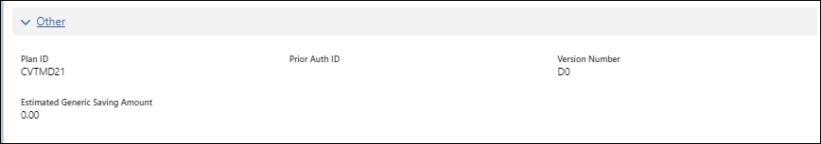

|  |  |
| --- | --- |
| **Field** | **Description** |
| **Plan ID** | ID of the Plan in which the member is enrolled |
| **Prior Auth ID** | ID of the Prior Authorization, if applicable |
| **Version Number** | Not applicable |
| **Estimated Generic Saving Amount** | Not applicable |

Top of the Document

|  |
| --- |
| **COB Segment Screen** |



From the **Transmission Details Screen**, click the **COB Segment Button**

**Note:** The COB Segment Button is dynamic and displays applicable claims.

**Result:** COB Segment Screen Populates

|  |  |  |
| --- | --- | --- |
| **Field** | **Description** | |
| **Other Payer Count** | Number of payers  **Note:** can be 1-9 | |
| **Other Payers Total Paid Amount** | Patients 1-9 accumulated paid amount | |
| **Patient (1-9) Paid Amount** | Specific payer accumulated paid amount | |
| **Benefits Stage Loop** | Fields included under this will either display a dollar format, or if no value, $0.00 | |
| **Field** | **Description** |
| Deductible Applied | Amount applied to deductible. |
| Initial Applied | The deductible amount paid prior to the specific claim processed. |
| Gap Applied | The GAP amount applied towards the specific claim processed. |
| Catastrophic applied | The Catastrophic amount applied towards the specific claim processed. |
| Med C Benefit Applied | The Med C amount applied towards the specific claim being processed. |
| Supplemental Benefit Applied | The Supplement Benefit amount applied towards the specific claim processed. |
| Med D Commercial Pricing Applied | The Med D Drug Commercial Pricing applied towards the specific claim processed. |
| Non-Med D Drug Commercial Pricing Applied | The Non-Med D Drug Commercial Pricing applied towards the specific claim processed. |
| Med D Drug-Supplemental Benefit Applied | The Med D Drug -Supplemental Benefit applied towards the specific claim processed. |
| Non-Med D Supplemental Benefit Applied | The Non-Med D Drug -Supplemental Benefit applied towards the specific claim processed. |
| Non-Med D Enhanced/OTC Drug Paid Under Med D Benefit | The amount applied towards the specific claim processed to Non-Med D Enhanced/OTC Drugs paid under Med D. |
| Member is Qualified Medicare Beneficiary (QMB) | The amount applied towards the specific claim processed to the QMB. |
| Payer Amount Paid | The amount paid towards the specific claim.  **Note:**Can display amount paid or “Information not Available” |
| **Reject Code** | Will be blank if there is a payer or patient paid amount. Refer to [Compass - Rejection Codes and Resolutions (Reject 01 – Reject ZN) (067649)](https://thesource.cvshealth.com/nuxeo/thesource/#!/view?docid=104c3318-95ba-42e2-bd05-17877b0a8045). | |

Top of the Document

|  |
| --- |
| **Related Documents** |

**Parent Document:** [CALL 0049 Customer Care Internal and External Call Handling](https://policy.corp.cvscaremark.com/pnp/faces/DocRenderer?documentId=CALL-0049)

[Compass - Rejection Codes and Resolutions (Reject 01 – Reject ZN) (067649)](https://thesource.cvshealth.com/nuxeo/thesource/#!/view?docid=104c3318-95ba-42e2-bd05-17877b0a8045)

Top of the Document

Not to Be Reproduced or Disclosed to Others Without Prior Written Approval

**ELECTRONIC DATA = OFFICIAL VERSION / PAPER COPY = INFORMATIONAL ONLY**